📁 7. Honeycomb Paper Expander Series
Designed for converting waste cardboard boxes and kraft paper into eco-friendly cushioning materials, ideal for applications in e-commerce, export packaging, and logistics cushioning.

📁 7. 膨切机产品线（Honeycomb Paper Expander Series）
用于废纸箱、牛皮纸转化为环保缓冲材料，应用于电商、出口包装、物流缓冲填充场景
🔍 Quick Selection快速选型
🖼️Front View外观 | 🏗️OVERALL | 🆔Model型号 | 📥Feed宽度 |  | 💰Price 价格
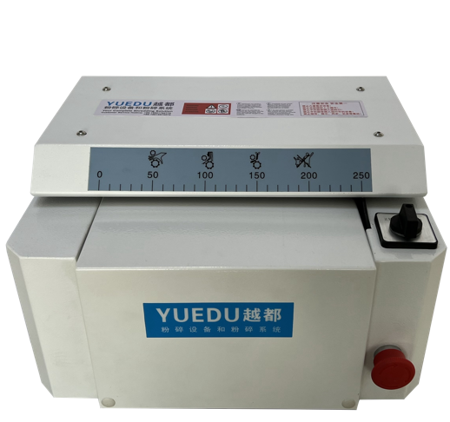 | 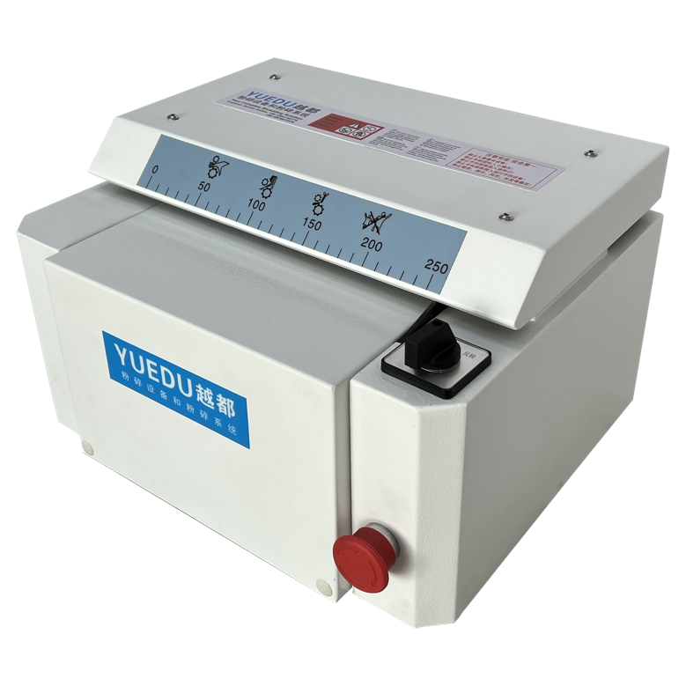 | YD-PQJ320W | 255mm |  | RMB 13,900
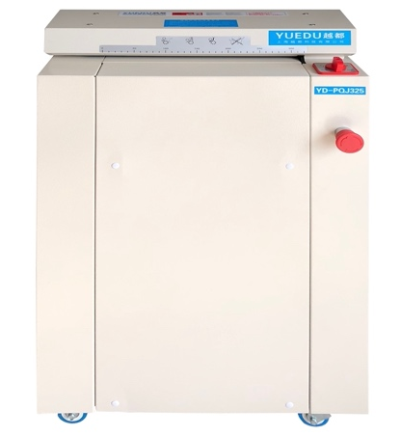 | 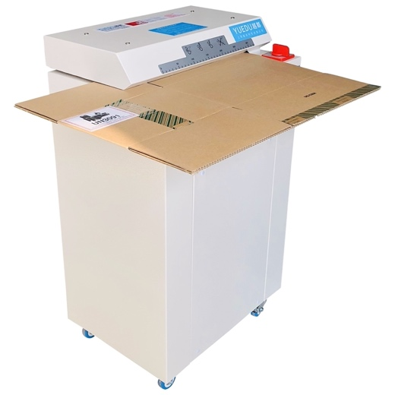 | YD-PQJ325W | 325mm |  | RMB 17,500
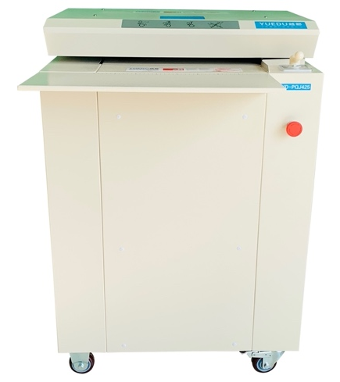 | 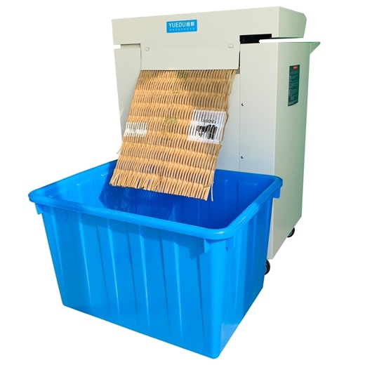 | YD-PQJ4250W | 425 mm |  | RMB 29,700
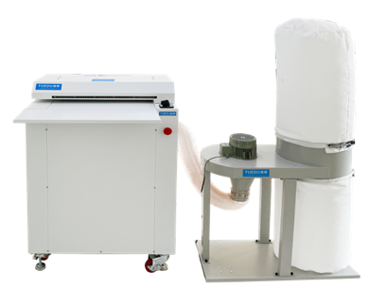 | 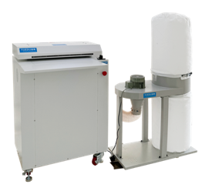 | YD-PQJ500W | 500 mm |  | RMB 37,500
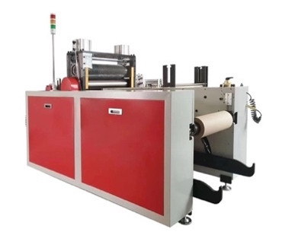 | 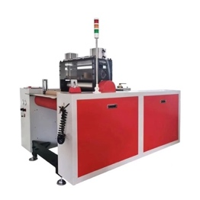 | YD-PQJFW500 | 510 mm |  | RMB 250,000

📄 YD-PQJ500W YD-PQJ425W YD-PQJ325W YD-PQJ320W
🖼️ Product Overview产品概览
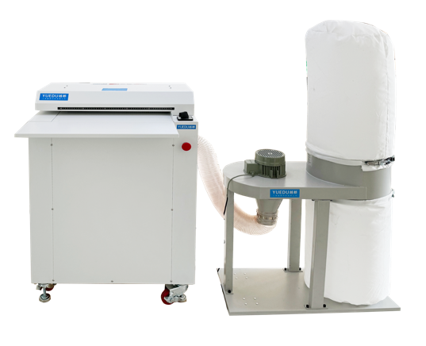
Model: YD-PQJ500W | Model: YD-PQJ425W | Model: YD-PQJ325W | Model: YD-PQJ320W
🧩 Application Scenarios应用场景
Fig. 1 OPEN INLET | Fig. 2 REAR VIEW | 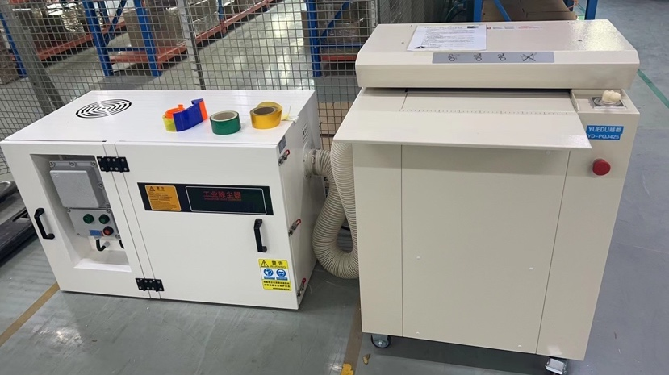  Fig. 3 EMERSON – CUSTOM | 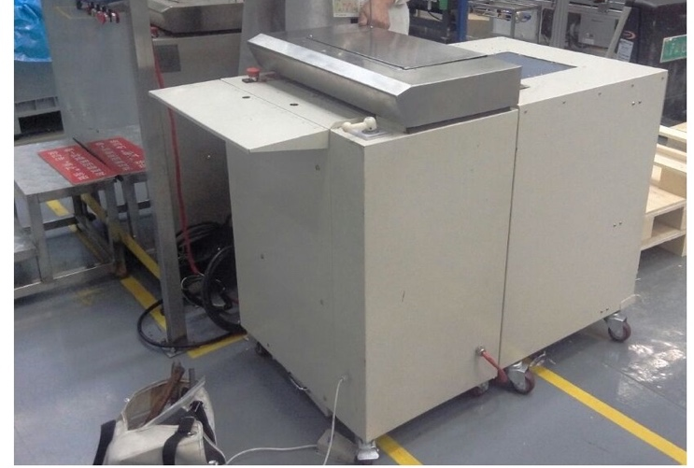  Fig. 4 ROYAL PET – CUSTOM
✂️ Shreddable Materials可以粉碎的物品
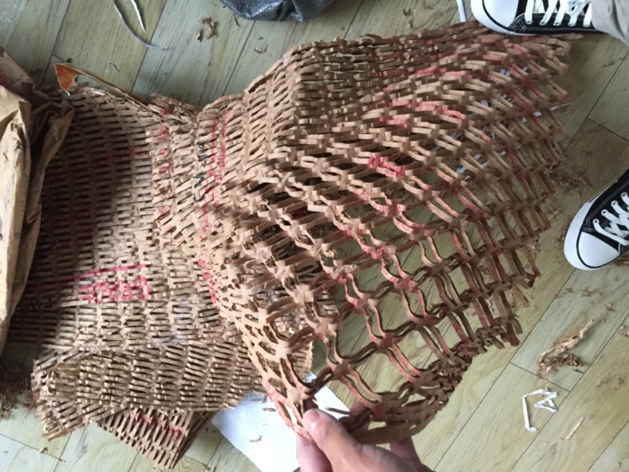 | 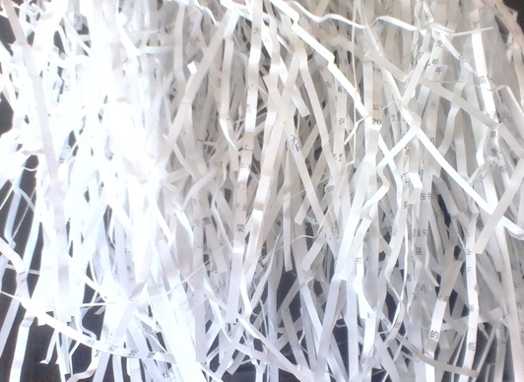 | 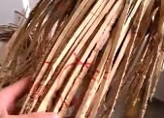 | 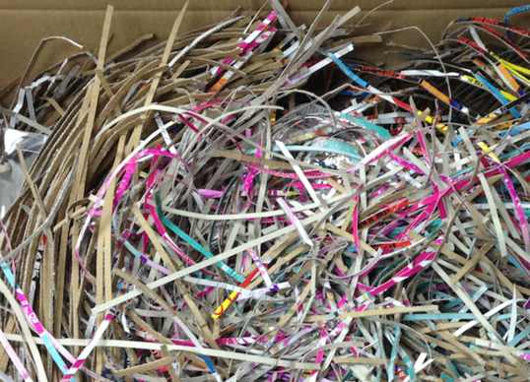
🔧 Technical Specifications主要参数
Item No | YD-PQJ500W | YD-PQJ425W | YD-PQJ325W | YD-PQJ320W
Feed Width | 500mm | 425mm | 325mm | 255mm
Feed Height | 20mm | 20mm | 14mm | 8mm
Packing Mat Grid | 5*80mm or  5mm Strip cut | 5*100mm or  5mm Strip cut | 5*60mm or  5mm Strip cut | 3*45mm or  3mm Strip cut
Packing Mat Grid | 5-7 ply Box or 40-70 paper A4/70g | 5-7 ply Box or 40-70 paper A4/70g | 3-5 ply Box or 30-40 paper A4/70g | 3-5 ply Box
Power Supply | 220V/50Hz | 380V/50Hz | 220V /50Hz | 220V/50Hz
Motor Power | 2.6KW | 2.8KW | 1.8KW | 100W
Net Weight | 145Kg | 164Kg | 88Kg | 30KG
Dimension(mm) | W723*D702*H1035 | W700*D680*H970 | W500*D355*H800 | W387*D316*H255
RMB Pricing  (Inc. CN Tax 13%) | 29900 / 37500(inc. vacuum cleaner) | 29700 | 17500 | 13900

📄 YD-PQJ500W inc. vacuum cleaner
🖼️ Product Overview产品概览
 | 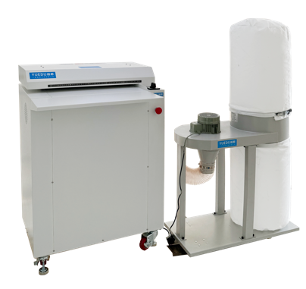 |  | 
📸On-Site User Video YD-PQJ500W | 工作视频（客户现场）
On-Site 1 | On-Site 2 |  |  | 
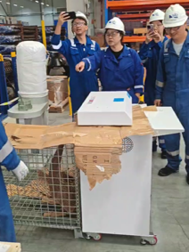 | 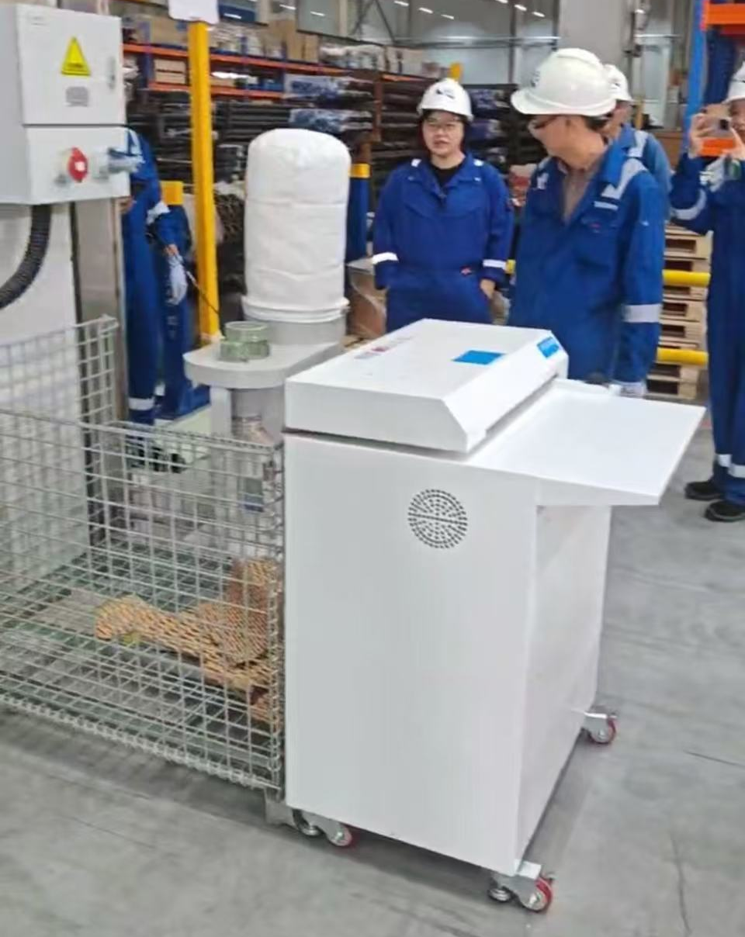 | 1 | Cardboard Perforator YUEDU YD-PQJ500W  https://youtube.com/shorts/JovtVIr5rUs | 【越都YD-PQJ500W膨切机】 https://b23.tv/1wB9NqZ
 |  | 2 | Customized Shredding Solution  https://youtube.com/shorts/rYT4tzDDXH0 | 【纸板的网状蓬松效果】 https://b23.tv/lvtnkKu
 |  | 3 | cardboard perforator | YUEDU  https://youtube.com/shorts/CjXOfb08rH4 | 【越都助力跨国公司仓库运营】 https://b23.tv/gjTbFyN
🔧 Technical Specifications主要参数
Model: YD-PQJ500W | 型号：YD-PQJ500W
Specifications:  • Input Width: 500mm  • Input Thickness: 20mm  • Shredding Output Size: 5×76mm grid  • Feeding Speed: 15 meters per minute | 产品参数：  入口宽度：500mm，入口厚度20mm  粉碎后尺寸：5*76mm网格状  进料速度：15米每分钟
Main Shredding Unit:  • Power: 2600W  • Voltage: 100-115V or 220-240V  • Net Weight: 145kg  • Gross Weight: 170kg | YD-PQJ500W粉碎主机部分：  功率：2600W  电压：100-115V 或 220-240V  净重145KG ，毛重170KG
Optional Dust Removal System:  • Power: 750W/220V  • Air Volume: 1500M³/H, Air Speed: 35M/S  • Dimensions: 0.8×0.4×1.5M  • Weight: 23kg | 除尘系统部分参数（可选配置）：  功率 750W/220V  风量 1500M/H，风速 35M/S  尺寸 0.8*0.4*1.5M  重量 23KG
Total Power: 3350W, Single Phase, 220V (Optionally available in 110V)  Total Weight excluding dust removal system: 165kg (including shredding unit and export packaging)  Total Weight with Dust Removal System: 188kg (Including main unit, dust removal system, and export packaging) | 总功率：3350W, 单向，220V （可做110v）  总重量：165㎏ （不含吸尘器、含主机、含出口包装）  总重量：188㎏ （含主机和吸尘器以及出口包装）
Overall Dimensions: W500×D355×H800mm (Including main unit, dust removal system, and export packaging) | 外形尺寸：W500*D355*H800mm （含主机和吸尘器以及出口包装）

📄 YD-PQJFW500 | High-speed honeycomb paperboard die-cutting machine
♻ Convert Kraft Paper into Eco-Friendly Honeycomb Packaging
200m/min High-Speed Punching & Rewinding
Ideal for Logistics, E-Commerce & Sustainable Packing
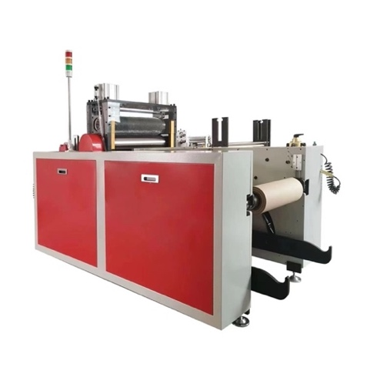 | 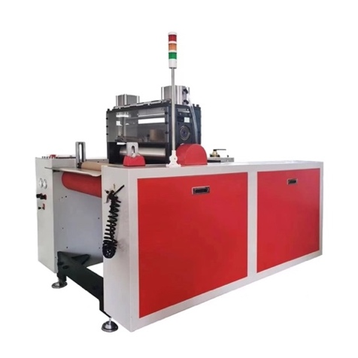 | 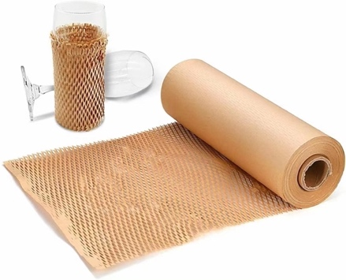
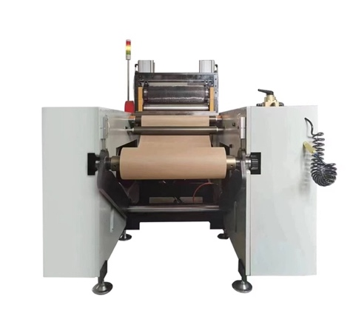 | 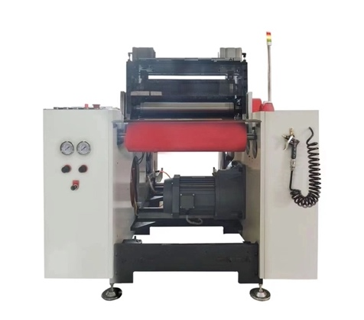 | 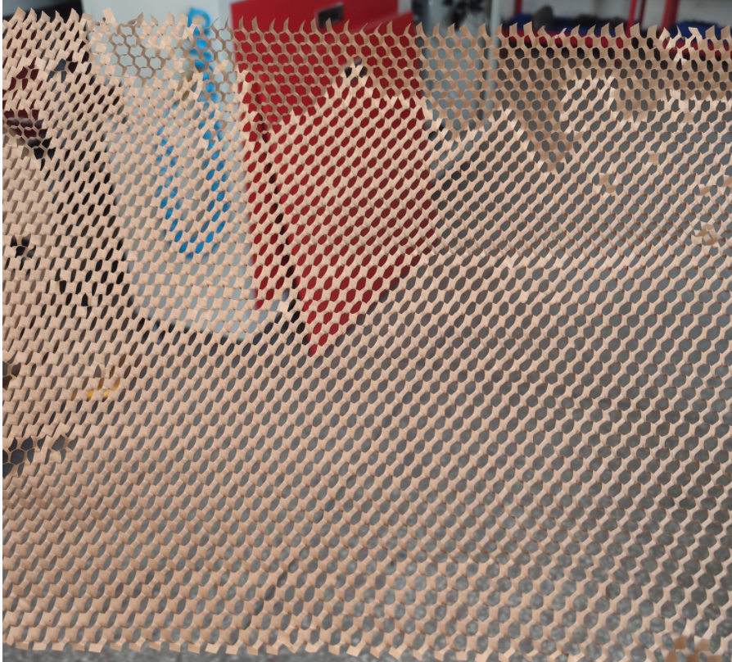
🌟 Key Advantages
✅ Auto-forming honeycomb mesh  Built-in tension control for consistent output  ✅ 7” Touchscreen + PLC Control  Simple interface and precise operation | ✅ Seamless integration  Compatible with packing lines & automation  ✅ One-time investment  Save long-term cost on plastic/foam fillers
📐 Product Specifications
Model | YD-PQJFW500
Material | Kraft Paper (60g–120g)
Speed | Up to 200 meters/min
Feeding Width | 200–510mm
Motor Power Supply | 5KW, 3-phase 380V 50Hz
Machine Size | 1950×1314×1402mm
Machine Weight | 1800KG

